

Solutions – DAY 1

* My first Java program – Example1.java
* Variables – Example2.java
* Test your skills – testyourskills.java

My first Java program

Open your text editor and type the following lines of code:

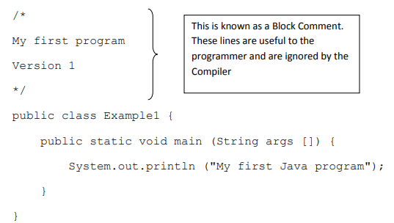

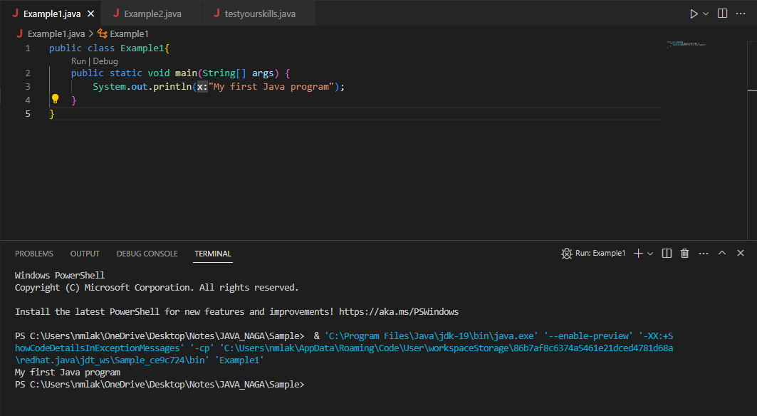

Variables and Data Types

Variables

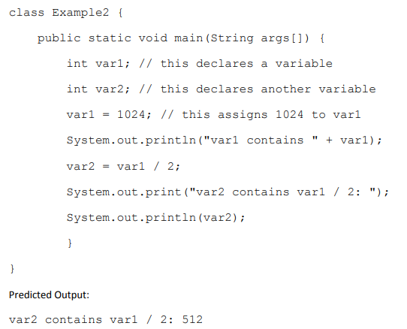

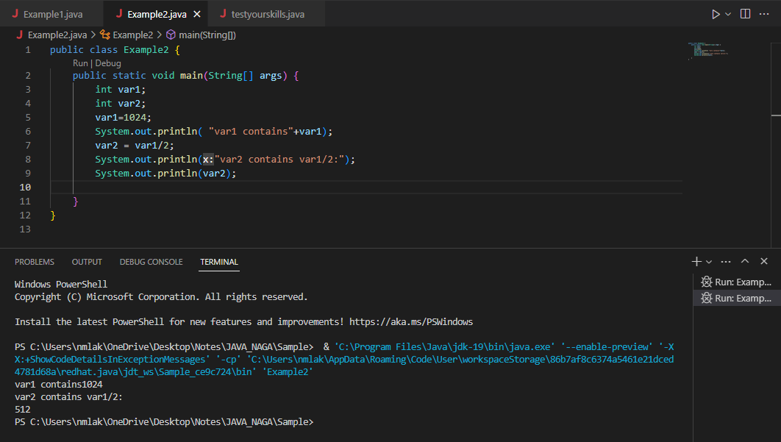

Test your skills

As we saw above, we used the ‘/’ to work out the quotient of var1 by 2. Given that ‘+’ would perform addition, ‘-‘ subtraction and ‘\*’ multiplication, write out a program which performs all the named operations by using two integer values which are hard coded into the program.

Hints:

1. You need only two variables of type integer
2. Make one variable larger and divisible by the other
3. You can perform the required calculations directly in the print statements, remember to enclose the operation within brackets, e.g. (var1-var2)

